Project Design Phase-II

Data Flow Diagram & User Stories

|  |  |
| --- | --- |
| Date | 1 NOVEMBER 2022 |
| Team ID | PNT2022TMID41904 |
| Project Name | Project - IoT based Safety gadget for child safety monitoring and notification |
| Maximum Marks | 4 Marks |

# Data Flow Diagrams:

A Data Flow Diagram (DFD) is a traditional visual representation of the information flows within a system. A neat and clear DFD can depict the right amount of the system requirement graphically. It shows how data enters and leaves the system, what changes the information, and where data is stored.

# FLOW:-

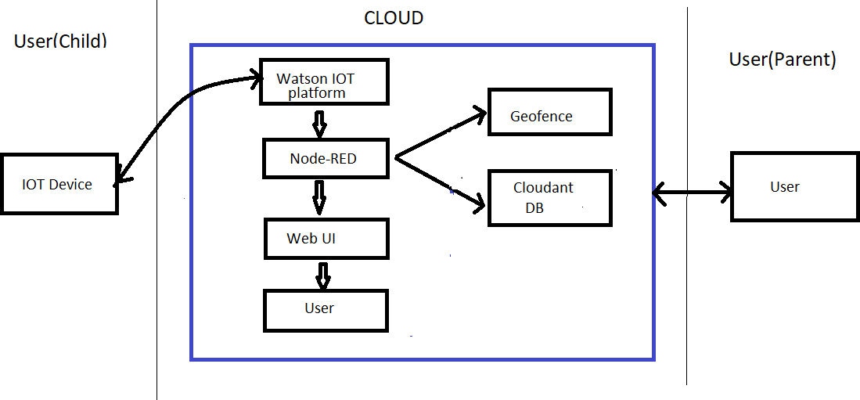

**User Stories**

Use the below template to list all the user stories for the product.

|  |  |  |  |  |  |  |
| --- | --- | --- | --- | --- | --- | --- |
| **User Type** | **Functional Requirement**  **(Epic)** | **User Story Number** | **User Story / Task** | **Acceptance criteria** | **Priority** | **Release** |
| Customer (Web user) | Registration | USN-1 | As a user, I can register for the application by entering my email, password, and confirming my password. | I can access my account / dashboard | High | Sprint-1 |
|  |  | USN-2 | As a user, I will receive confirmation email  once I have registered for the application | I can receive confirmation  email & click confirm | High | Sprint-1 |
|  |  | USN-3 | As a user,I can register for the application through Facebook | I can register & access the dashboard with Facebook Login | Low | Sprint-2 |
|  |  | USN-4 | As a user, I can register for the application  through Gmail |  | Medium | Sprint-1 |
|  | Login | USN-5 | As a user, I can log into the application by entering email & password |  | High | Sprint-1 |
|  | Dashboard | USN-6 | As a User, I can view the Dashboard | I can view the locations  which is stored in the database of  the child via dashboard | High | Sprint-2 |
| Customer Care Executive |  | USN-7 | As a customer care executive,I will detect the problems | I will detect the problems and correct them if the  device face any | Medium | Sprint-3 |
| Administrator |  | USN-8 | As an administrator, I ensure the efficiency  of the device | I will ensure  efficiency,cost,etc | High | Sprint-4 |